**Daily meeting logs**

10/24/18

All members caught up and aware of what’s going on

Tasks need assigned, sprint started officially.

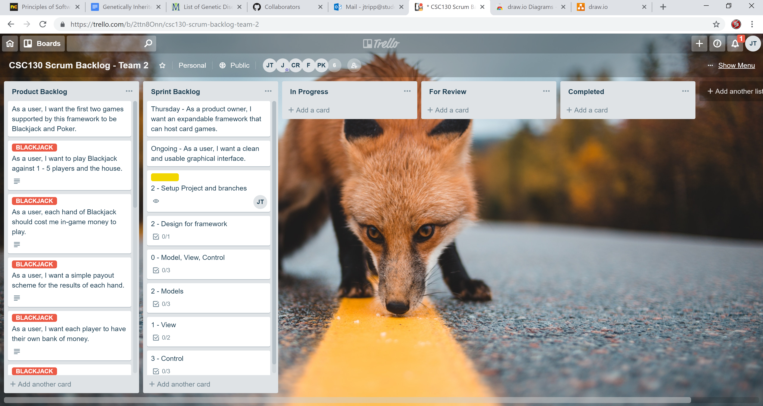

10/25/18

I was absent but contacted through discord.

Group divided into tasks to set up model view and control for framework.

Mostly done sprint ahead of schedule.

Started dividing into groups to divide and conquer for blackjack and poker games.

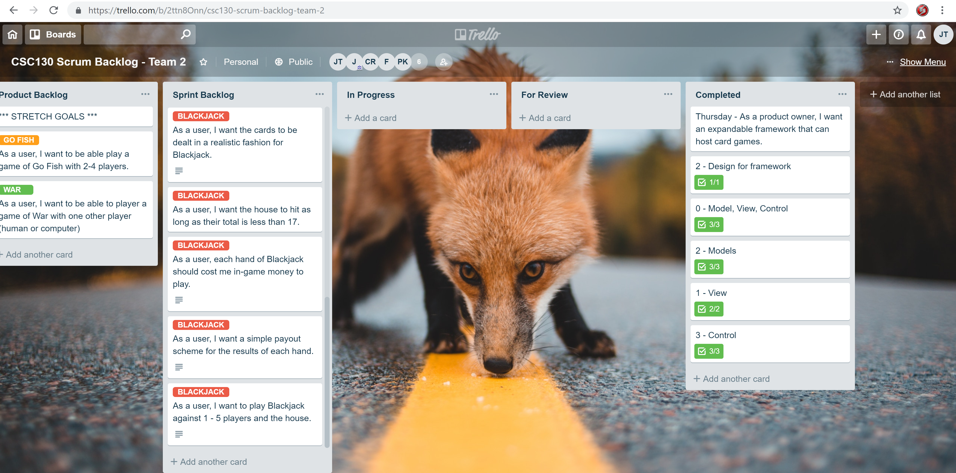

10/26/18

Design started for blackjack.

Controllers for each game setup.

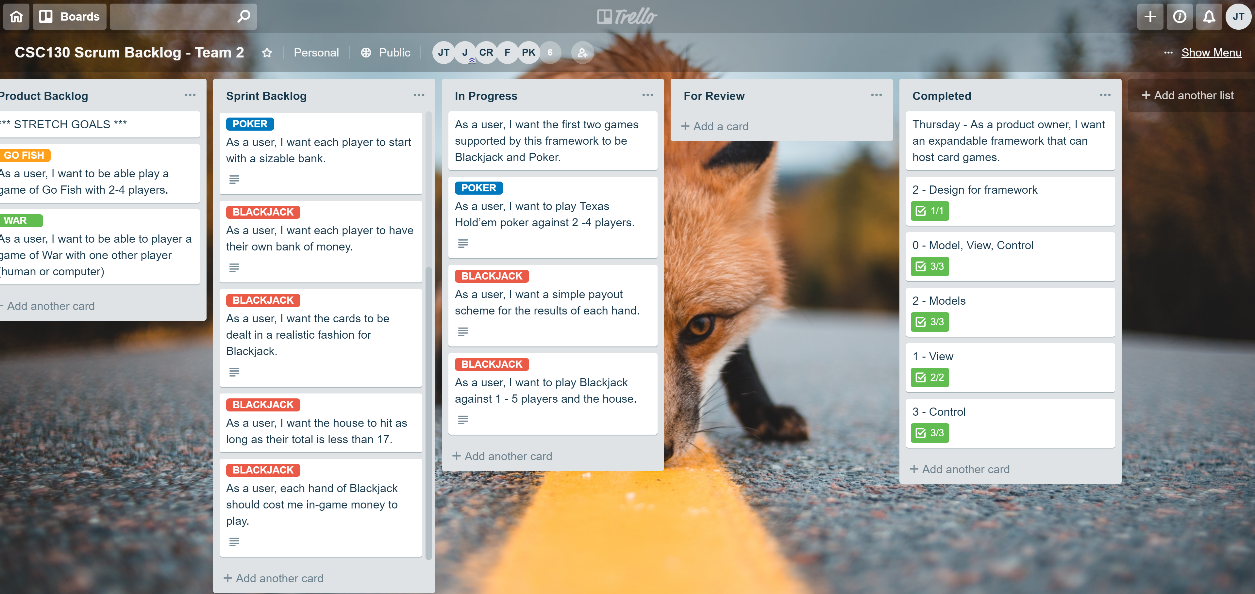

10/29/18

Team is doing fine just need to work so I just let them work. About 35% done.

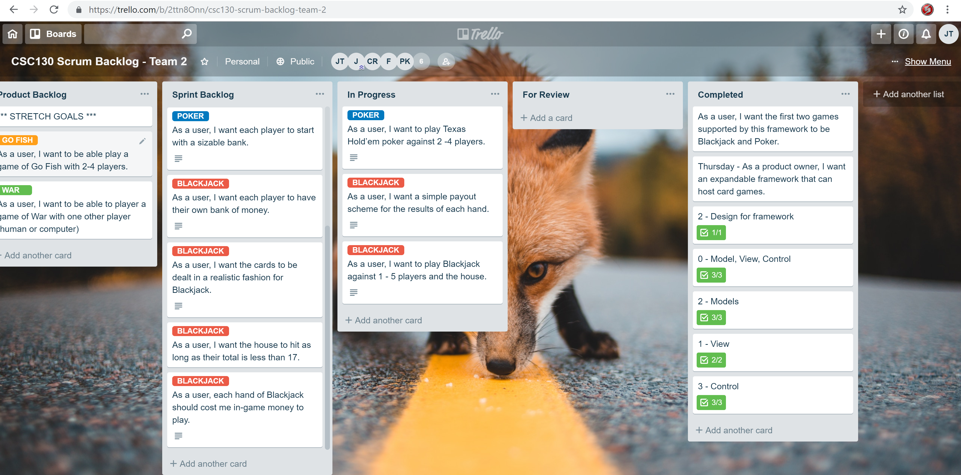

10/30/18

Progress is moving but teams just need more time. I need to get the view working for paige and damon to connect the controller. Just need to hammer it out.

Probably won’t get to

